Angel Zhou

Zuri Harvell

Raymond Huffman

July 30, 2014

Make sure your proposal contains the following:

* What is your prototype about?
* What will people learn from your experience?
* Will it be interactive or is it something people will watch?
* If interactive, what can the user do?
* How would your design fit in with the Exploratorium?
* Draw a diagram that explains how your prototype works.
* Are there any existing systems that are similar to yours? Name and link them.

A Caterpillar Game: This program will be a prototype of the well-known caterpillar game. A caterpillar will travel around the screen, trying to eat the next prime number. If the caterpillar eats the wrong prime number in the sequence, then the game will be over. This feature will be programmed using while loops and if statements. On the other hand, if the caterpillar eats the correct integer, a new segment will elongate the length of the snake. This feature will utilize for loops. This game will be very interactive, as the user as to use the arrow keys to control the direction of the caterpillar’s travels. From this experience, the user will be able to test their knowledge of prime numbers and maneuver the caterpillar in a fashion that will not cause the game to end (either by making the caterpillar run into its own body or by eating the wrong prime number.) This program is similar to the Pac-Man exhibit at the Exploratorium because it encourages the user to think logically and methodically to avoid losing the game.

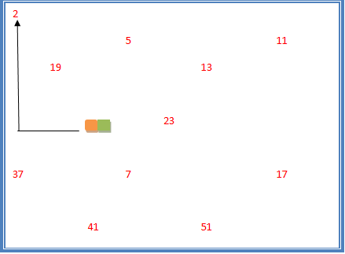

This is an image of what the program would look like and how the caterpillar would function.

**[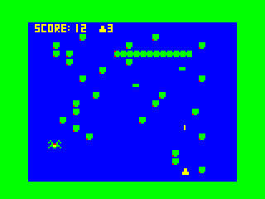](http://www.kongregate.com/games/uchiha/classic-snake-game)**

Click on the picture to play a similar snake game!

Also include descriptions of the:

* Easy Version: ABC

The easy version will be the caterpillar game with the alphabet instead of numbers. When one letter is eaten, another appears so that the number of characters available to run into is always the same. If the user successfully eats all the alphabets in sequence, then the letters on the screen will loop back to the beginning of the alphabet.

* Clever Version: user chooses sequence to eat

In this version, there will be many options of modes, meaning that the user can play to test their knowledge of the sequence of the alphabet, prime numbers or powers of 2. There will also be an instructions page before playing (and a start and pause button) to inform the user of the rules to play and the methods to move the caterpillar.

* Advanced Version

In the advanced version, sound effects will be included for different events that happen (when the user wins, loses, eats the wrong sequence).

Finally, indicate who had which roles (a team member can be more than one, let them pick):

* Designer: Angel
* Programmer: Raymond
* Artist: Zuri